Physics 30 Lesson 11 Interference of Light

Light – wave or particle?
That light carries energy is obvious to anyone who has focused the sun's rays with a magnifying glass on a piece of paper and burned a hole in it. But how does light travel and in what form is this energy carried? Energy can be carried from place to place in basically two ways: by particles or by waves. In the first case, material bodies or particles can carry energy, such as a thrown baseball or the particles in rushing water. In the second case, water waves and sound waves, for example, can carry energy over long distances. In view of this, what can we say about the nature of light? Does light travel as a stream of particles away from its source; or does it travel in the form of waves that spread outward from the source? Historically, this question has turned out to be a difficult one. For one thing, light does not reveal itself in any obvious way as being made up of tiny particles nor do we see tiny light waves passing by as we do water waves. The evidence seemed to favour first one side and then the other until about 1830 when most physicists had accepted the wave theory. By the end of the nineteenth century, light was considered to be an electromagnetic wave (see Lesson 24). Although modifications had to be made in the twentieth century (Lessons 28 to 30), the wave theory of light has proved very successful. We now investigate the evidence for the wave theory and how it has explained a wide range of phenomena.

The wave theory of light
The Dutch scientist Christian Huygens (1629-1695), a contemporary of Newton, proposed a wave theory of light that had much merit. (Refer to Pearson pages 684 to 685.) Still useful today is a technique he developed for predicting the future position of a wave front when an earlier position is known. This is known as Huygens' principle and can be stated as follows:

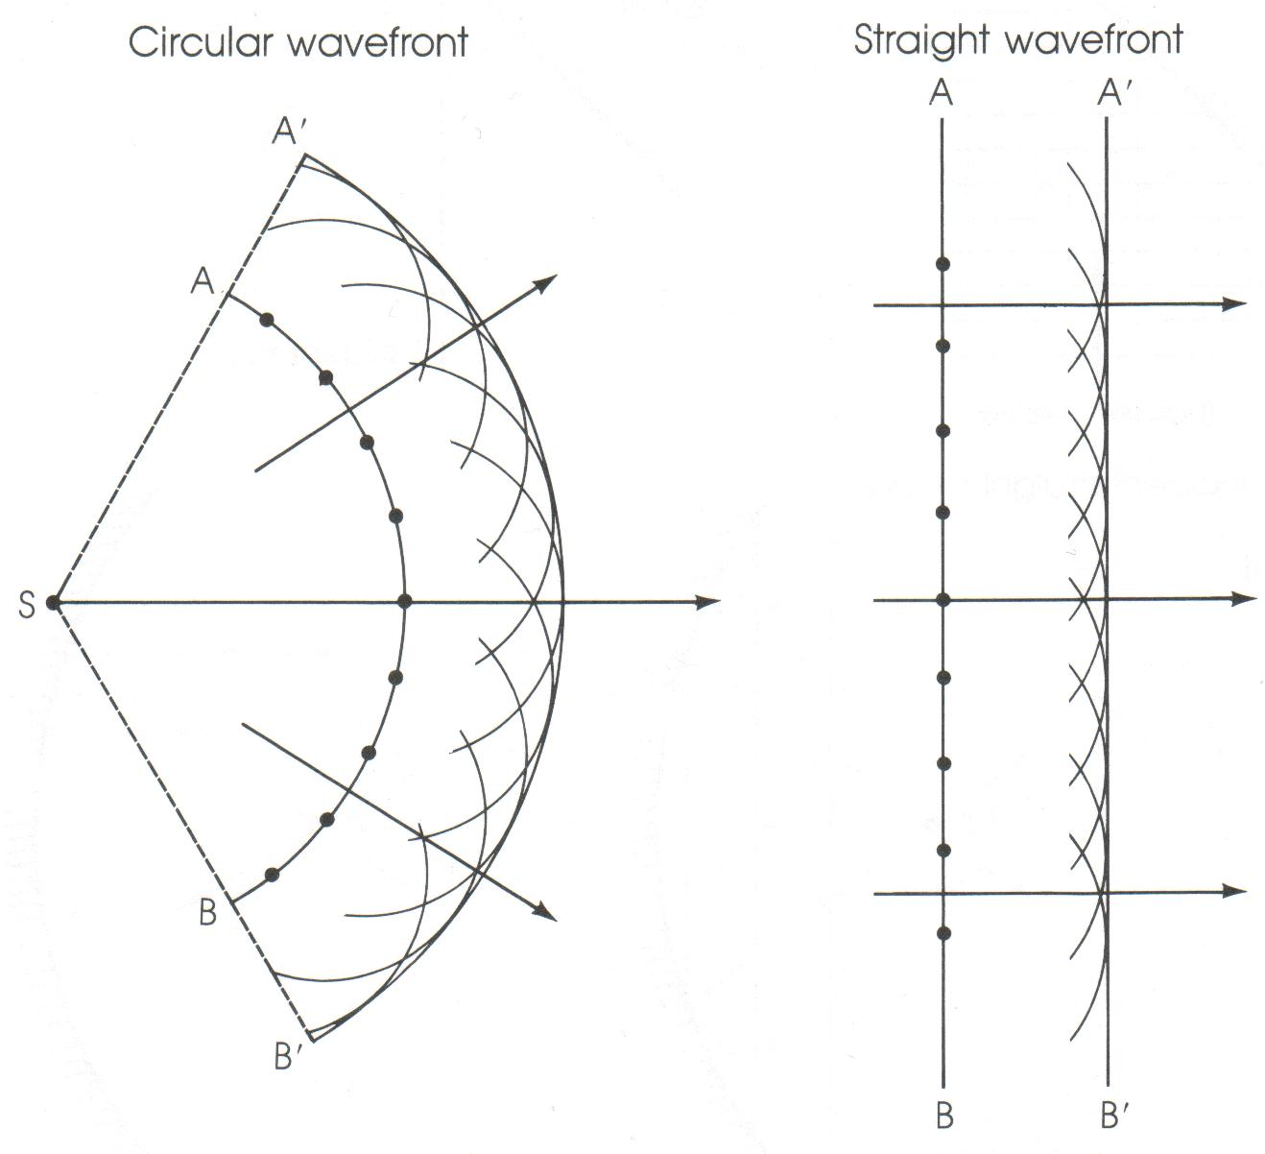
Every point on a wavefront can be considered as a point source of tiny secondary wavelets that spread out in front of the wave at the same speed as the wave itself. The surface envelope, tangent to all the wavelets, constitutes the new wavefront.

As a simple example of the use of Huygens' Principle, consider the circular and straight wavefronts AB at some instant in time as shown to the right. The points on the wavefront represent the centres of the new wavelets, seen as a series of small semi-circles. The common tangent to all these wavelets, the line A'B', is the new position of the wavefront a short time later.

Huygens' principle is particularly useful when waves impinge on an obstacle and the wave fronts are partially interrupted. Huygens' principle predicts that waves bend in behind an obstacle. The bending of waves behind obstacles into the “shadow region” is known as diffraction. Since diffraction occurs for waves, but not for particles, it can serve as one means for distinguishing the nature of light.

Does light exhibit diffraction? In the mid-seventeenth century, a Jesuit priest, Francesco Grimaldi (1618-1663), had observed that when sunlight entered a darkened room through a tiny hole in a screen, the spot on the opposite wall was larger than would be expected from geometric rays. He also observed that the border of the image was not clear but was surrounded by coloured fringes. Grimaldi attributed this to the diffraction of light. Newton, who favoured a particle theory, was aware of Grimaldi's result. He felt that Grimaldi's result was due to the interaction of light corpuscles (ie. “little bodies”) with the edges of the hole. If light were a wave, he argued, the light waves should bend more than that observed. Newton's argument seemed reasonable, yet diffraction is noticeable only when the size of the obstacle or the hole is on the order of the wavelength of the wave. Newton did not know that the wavelengths of visible light were incredibly tiny, and thus diffraction effects were very small. Indeed this is why geometric optics using rays is so successful – normal openings and obstacles are much larger than the wavelength of the light, so relatively little diffraction or bending occurs.

In 1801, a key experiment was performed by the brilliant Thomas Young (1773 – 1829). (Refer to Pearson pages 685 to 690.) Young directed light through two parallel narrow slits a small distance apart. The light was then seen on a screen a few meters away. If light consisted of particles the result would be two bright fringes on the screen (screen b below), but the actual results were quite different. Instead of two bright fringes, there were a series of alternating bright and dark fringes (screen c below).

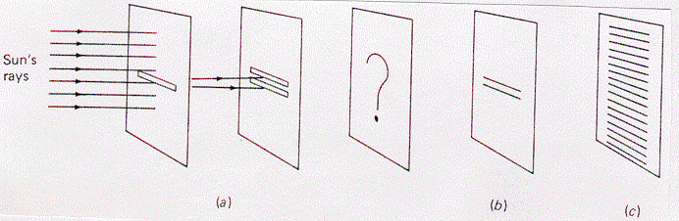

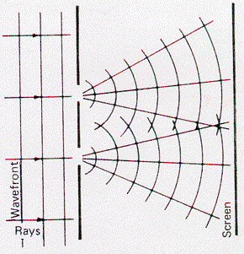
Young reasoned that he was seeing a wave interference pattern caused by the diffraction of light through each of the slits. Light diffracting through one of the slits interfered with the diffracted light from the other slit.

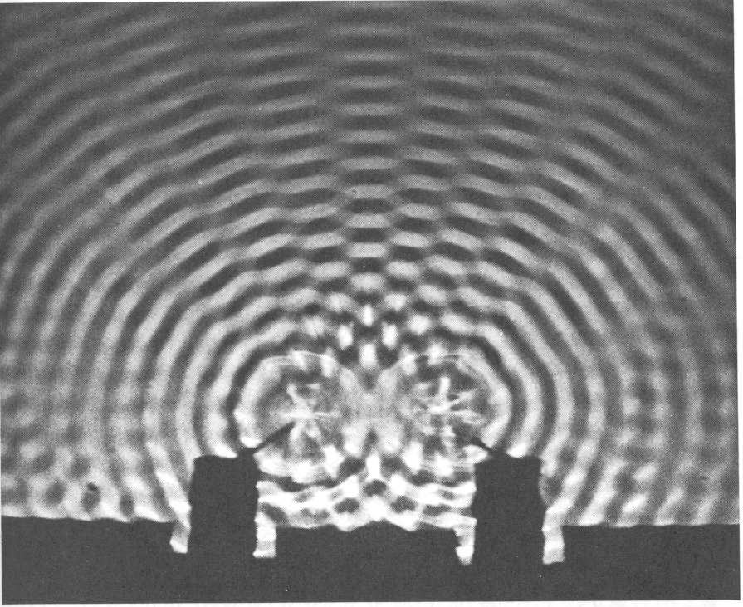
Interference of light
antinodes
nodes
d
Recall from Physics 20 that when two waves meet they interfere with each other in an additive fashion. The waves combine either constructively or destructively depending on the situation. For two-dimensional mechanical waves consider the situation where two sets of waves are being generated at the same time and in the same phase a distance (d) from each other. When crests meet crests and troughs meet troughs, constructive interference occurs and these are called antinodes or maxima. When crests meet troughs, complete destructive interference occurs and these are called nodes or minima. Notice the pattern of antinodes with nodes in between them. (Refer to pages 425 to 428 in Pearson for a discussion of two-dimensional wave interference.)

To understand how an interference pattern is produced, consider the diagrams below. Two waves of wavelength λ are shown to originate from two vibrating sources (S₁ and S₂) a distance d apart. While waves spread out in all directions, we will focus our attention on the two wave trains shown in each of the following diagrams. In diagram (a) the waves travel the same path length – when they meet they are in phase and constructive interference occurs resulting in a maximum or antinode.
S₁
S₂
d
a) constructive interference
S₁
S₂
b) constructive interference
λ

There will also be constructive interference if the path difference is one wavelength or a whole number multiple of wavelengths (1λ, 2λ, 3λ, nλ) as shown in diagram (b).

However if the path difference is ½λ or 3/2λ or 5/2λ and so on, the result is destructive interference resulting in nodes or minima. This is illustrated in diagram (c).
S₁
S₂
½λ
c) destructive interference

Derivation of double source interference equations
x
θ
θ
d
L
Q
R
S
A
B
C

The variables are:
d – distance between two coherent wave sources
L – the distance from the wave sources to the viewing “screen” or area
x – the distance from the central maximum (point S) to the node or antinode of interest
λ – the wavelength
θ – the angle from the centre line to the node or antinode of interest

We are interested in deriving an equation that relates x (RS) with L (QS) and d (AC) and λ. We note that for constructive interference to occur at point R, the path difference (BC) between AR and CR must be a whole number multiple (n = 1, 2, 3,…) of a wavelength (λ).
∴ BC = nλ
ΔABC is similar to ΔQRS while ∠B and ∠S are 90º.

$\text{tan} θ = \frac{\text{RS}}{\text{QS}} = \frac{x}{L}$ (1) and $\text{sin} θ = \frac{\text{BC}}{\text{AC}} = \frac{nλ}{d}$ (2)

rearranging equation (2) we get our first useful formula
In order to relate equations (1) and (2) we note

sin θ ≅ tan θ for small angles of θ (0º to 20º)

∴ $\frac{nλ}{d} = \frac{x}{L}$

rearranging this equation gives us our second useful formula $λ = \frac{d x}{n L}$

Using the double-source interference equations
The equations that were derived in the previous section are:
These equations are on your formula sheet.
These equations may be made from the formula sheet by subtracting ½ from n.

where:
λ wavelength (m)
θ angle from central line to fringe
n order of fringe
L distance from slits to screen (m)
x distance from central bright fringe to nth fringe (m)
d distance between slits (m)

A student doing Young’s experiment finds that the distance between the central bright fringe and the seventh nodal line is 6.0 cm. If the screen is located 3.0 m from the two slits, whose separation is 220 μm, what is the wavelength of the light?
x = 0.060 m
L = 3.0 m
d = 220 x 10⁻⁶ m
n = 7
λ = ?

An interference pattern is produced through two slits which are 0.045 mm apart using 550 nm light. What is the angle to the 4th bright fringe from the central line?
d = 0.045 x 10⁻³ m
n = 4
λ = 550 x 10⁻⁹ m

An interference pattern is formed on a screen when a helium-neon laser light (λ = 632.8 nm) is directed through two slits. If the slits are 43 μm apart and the screen is 2.5 m away, what will be the separation between adjacent nodal lines?

When a question asks for the separation between nodes or antinodes, set n = 1 and use the constructive interference equation. The fringes are all the same distance apart, whether they are bright or dark.
x = ?
L = 2.5 m
d = 43 x 10⁻⁶ m
n = 1
λ = 632.8 x 10⁻⁹ m

Practice problems
1. A slide containing two slits 0.10 mm apart is 3.20 m from the viewing screen. Light of wavelength 500 nm falls on the slits from a distant source. How far from the centre line will the 9th bright fringe be? How many bright fringes are possible?
(0.144 m, 200)

2. In Young's experiment, the two slits are 0.04 mm apart and the screen is located 2.0 m away. The third order bright fringe is displaced 8.3 cm from the central fringe.
A. What is the frequency of the monochromatic light? (5.4 x 10¹⁴ Hz)
B. Where will the second dark fringe be located? (4.15 cm)

Hand-in assignment
- Light of frequency 6.0 x 10¹⁴ Hz is incident on a pair of straight parallel slits which are 5.0 x 10⁻⁵ m apart. Antinodal lines are produced in the region beyond the slits. What is the maximum number of antinodal lines in the interference pattern? (Hint, what angle would the last antinode occur at?) (100)
- Yellow light of wavelength 615 nm is incident on a double slit where slits are 1.3 mm apart. At what angle will the fifth order antinodal line appear? (0.14º)
- How many antinodal lines exist in an interference pattern when radiation of 555 nm passes through slits which are 0.10 mm apart? (180)
- Light of frequency 6.09 x 10¹⁴ Hz is incident on a pair of straight parallel slits and produces an interference pattern on a screen 7.0 m away. If the fringe spacing on the screen is 2.5 cm, determine the distance between the slits. (0.138 mm)
- Light of frequency 4.8 x 10¹⁴ Hz is incident on a pair of straight parallel slits where the slits are 0.16 mm apart. It creates an interference pattern on a screen 8.0 m away. What is the distance from the centre of the pattern to the fourth bright line? (0.13 m)
- A flat observation screen is placed at a distance of 4.5 m from a pair of slits. The separation on the screen between the central bright fringe and the first order bright fringe is 0.037 m. The light illuminating the slits has a wavelength of 490 nm. Determine the slit separation. (6.0 x 10⁻⁵ m)
- In a Young’s double slit experiment the separation between the central bright fringe and the first order bright fringe is 2.40 cm for 475 nm light. Assuming that the angles that locate the fringes on the screen are small, find the separation between fringes when light has a wavelength of 611 nm. (3.09 cm)
- In a Young’s double-slit experiment, the angle that locates the second-order bright fringe is 2.0º. If the slit separation is 3.8 x 10⁻⁵ m, what is the wavelength of the light? (6.6 x 10⁻⁷ m)
- Red light of wavelength 600 nm passes through two parallel slits. Nodal lines are produced on a screen 3.0 m away. The distance between the first and tenth nodal lines is 5.0 cm. What is the separation of the slits? (3.24 x 10⁻⁴ m)
- In an interference experiment, red light with a wavelength of 6.0 x 10⁻⁷ m passes through a double slit. On a screen 1.5 m away, the distance between the 1st and 11th dark bands is 2.0 cm.
  - What was the separation between the slits? (4.5 x 10⁻⁴ m)
  - What would the spacing be between adjacent nodal lines if blue light (450 nm) were used? (1.5 x 10⁻³ m)

