Physics 30 Lesson 13 Electrostatics
In lessons 1 to 4 we learned about momentum and the principle of conservation. Now we turn our attention to electricity and magnetism. A carry-over idea which will be used extensively, in fact throughout the course, is the idea of conservation. Conservation of different quantities is one of the most important principles in science.

In this lesson we shall discuss the properties of static (not moving) electric charges. In future lessons we will learn about dynamic (moving) electric charges which is called current electricity.

Historical background for electricity and magnetism (optional)
- Amber is a semi-transparent solid (yellow or brown) which is fossilized sap that oozed from softwood trees in the distant past. In 600 BC, Thales recognized that it had a property of attraction if rubbed vigorously against a cloth. This is the first recorded evidence of electrostatic attraction.

- Lodestone is a mineral (we call magnetite) that has a chemical formula of Fe₃O₄. It has the unusual property of attracting iron. When suspended or floated in a liquid it will always turn to one particular (North-South) orientation. It was used as a compass by the Vikings and the Chinese.

- Effluvium Theory. Lucretius was the first scientist to attempt an explanation of the attractive properties of both amber and lodestone. He suggested that the amber and lodestone had an efflux (or flowing out) of minute particles that would capture other small objects on their way back to the lodestone or amber. Lucretius did not attempt to distinguish between the type of attraction or take into account that amber and lodestone did not attract the same materials.

- de Magnete. Sir William Gilbert (1544 - 1603) was the chief physician to Queen Elizabeth I of England. He was also a scientist and, since Queen Elizabeth was very healthy, he had lots of time to work on his scientific ideas. He published his work in a document called “de Magnete” in the year 1600.

In de Magnete, Gilbert advanced the idea that the earth had a magnetic field. He reasoned that if small pieces of lodestone always line up the same way on a larger piece of lodestone and that they also align themselves in one direction with respect to the earth, then the earth must be a GIANT lodestone.

In de Magnete, Gilbert also attempted to draw a distinction between the properties of lodestone and amber (in other words, a distinction between electric and magnetic attraction). Gilbert introduced the term electric to describe bodies that attract the way amber does. The word ‘electric’ comes from ‘electron’ which is the Greek word for amber. Gilbert categorized the properties as:

electric (i.e., amber) | lodestone (magnetic)
i) attracts only when rubbed | i) always attracts
ii) attracts small particles of most objects | ii) attracts only iron or other ferromagnetic materials
iii) attracts from one center of attraction | iii) attracts from two centers (poles) of attraction
iv) only examples of attraction existed (in 1646, Sir Thomas Browne found examples of electric repulsion) | iv) attraction and repulsion had been observed

Sir William Gilbert was the first scientist to distinguish between electric and magnetic fields.

Electrostatics – Early ideas (optional)
Thales (600 BC) discovered that if substances like amber are rubbed with a piece of cloth, they can pick up little shreds of cloth or other small pieces of matter.

Gilbert (1600 AD) showed that many substances can be electrified by rubbing and as a result they can attract small bits of matter.

1. Benjamin Franklin’s One Fluid Theory

Ben Franklin (1706 - 1790) proposed that substances became charged because of a transfer of electric fluid when they were rubbed against each other. He reasoned that an excess of the electric fluid would result in a positive charge, while a lack of the fluid would result in a negative charge. He also believed that the fluid was composed of tiny (invisible to the eye) particles.

2. Dufay’s Two Fluid Theory.

Dufay, a French scientist (1700 AD) proposed that substances were composed of two different types of electric fluid. A positive fluid and a negative fluid. Neutral objects would contain equal amounts of each fluid and friction would cause an excess of one or the other fluid to accumulate on the object.

It is interesting to note that at the time of Franklin and Dufay, scientists like Lagrange, Euler and Bernoulli were developing theories about fluid flow, pressure/force relations, and hydraulics. Their theories were so successful it seemed a logical step to extend the theories into explaining electricity and magnetism. However, the later work of Faraday, Henry and others tended to support theories based on the motions of particles rather than fluids.

Electrostatics – Modern Theory
Refer to Pearson pages 512 to 515.

Today we find that both one fluid and two fluid theory models had merits. Today, we consider that all matter is composed of atoms and, in turn, the building blocks for each atom are protons and neutrons within the nucleus and electrons outside of the nucleus. Protons are positive, electrons are negative and neutral objects have equal amounts of each. In that sense, Dufay was correct. However, only electrons are transferred in the process of rubbing, so in that sense Franklin was correct.

Law of Charges

Like charges repel and unlike charges attract.

Conservation of Charge

When a neutral rubber rod is rubbed with a neutral piece of fur, the negative charge produced on the rod is numerically the same as the positive charge produced on the fur. The rod gained as many electrons as the fur lost. The net charge before rubbing the two together was zero and the net charge after adding the rubber to the fur will also be zero. In this closed system the net charge stays the same or, in other words, charge is conserved.

Measuring Charge

The unit for charge is the Coulomb (C) and the symbol for charge is q. A Coulomb (C) of positive charge is equal to the combined charge of 6.25 x 10¹⁸ protons. Since a proton cancels an electron, a Coulomb of negative charge is equal to the combined charge of 6.25 x 10¹⁸ electrons.

The charge on one electron is: q_{e} = –1.60 x 10⁻¹⁹ C.
The charge on one proton is: q_{p} = +1.60 x 10⁻¹⁹ C.

The number 1.60 x 10⁻¹⁹ is called the elementary charge. This is the smallest unit of charge that exists in the large-scale universe. All charges on objects are, in reality, whole number multiples of this number.

What is the charge on an object that has 750 excess electrons on its surface?

Electrons move, protons do not move

Protons exist within the nuclei of atoms, while electrons exist around the nuclei of atoms. Although they have the same amount of charge, protons are 1800 times more massive than electrons. Therefore, with far less inertia, electrons are far more responsive to electrical influences than are protons.

Distribution of Charges

All substances will allow electric charges to flow over or through them with different degrees of ease. Conductors are materials which allow electricity to flow easily through them (metals, ionic solutions, etc.) Insulators do not allow electricity to flow very easily (wood, plastics, glass, etc.) The terms conductor and insulator are relative, since some metals are better conductors than others and some materials insulate better than others.

Since like charges repel each other, charged particles on an object will try to move as far away from one another as possible. If the charges are on a conductor they are relatively free to move away from one another. If the charges are on an insulator (fur, plastic, ebonite rod, glass rod) the charges cannot easily move away from one another and are therefore forced to remain in close proximity to one another.

Negatively charged metallic sphere
Negatively charged plastic rod

−
−
−
−
−
−
−
−
− − − − − − −
−
−
− − − − − − −

On a conductor, the electrons are free to move as far away from one another as possible.
On an insulator, the electrons are forced to stay at one end of the rod since they are not free to flow to the uncharged end.

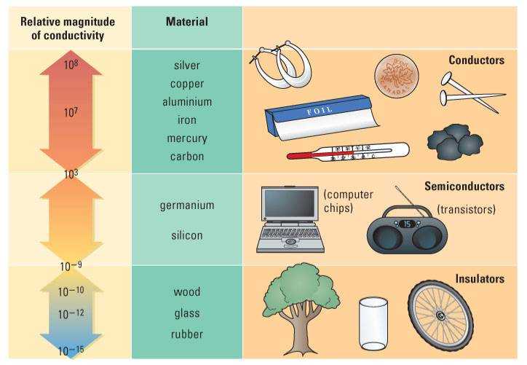

Relative conductivity of different materials.

Electroscopes
An electroscope is an instrument that will indicate the presence of a charge. One type of electroscope is the metal leaf electroscope. When neutral, the leaves hang straight down. But when the electroscope is given a charge, the leaves, because they have the same charge, will repel one another.
Neutral electroscope
Charged electroscope
metallic knob & stem
glass box
Insulating rubber stopper
metal foil

The tin foil straw electroscope is another type. When neutral, the straw hangs straight up and down. When charged, the support column will repel the straw which pivots on the support column. The greater the charge, the greater the deflection.

Neutral electroscope
Charged electroscope

Note:
- Both types of electroscopes will indicate the presence of charge but neither will give an exact reading of the amount of charge.
- You cannot tell whether the charge is positive or negative by just looking at an electroscope. A negatively charged electroscope will look identical to a positively charged electroscope. However, they will respond differently when a charged object is brought close to a charged electroscope.

Charging objects
Refer to Pearson pages 517 to 523.

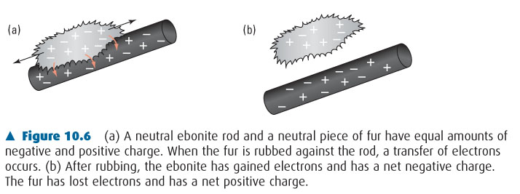
Charging By Friction
Some substances acquire an electric charge when rubbed with another substance. For example, an ebonite rod becomes negatively charged when rubbed with fur. We can explain this phenomenon with the help of the model of the electrical structure of matter. An atom holds on to its electrons by the force of electrical attraction to its positively charged nucleus. Some atoms or combinations of atoms exert stronger forces of attraction on their electrons than others. When ebonite and fur are rubbed together, work is done on the electrons. Some of the electrons from the fur are "captured" by the atoms of the ebonite, which exert stronger forces of attraction on them than do the atoms making up the fur. Thus, after rubbing, the ebonite has an excess of electrons (– charge) and the fur has a deficit (+ charge).

The same explanation holds for many other pairs of substances, such as glass and silk. The electrostatic series table below lists many of the substances that can be charged by friction. If two substances in the table are rubbed together, the substance that is higher in the table becomes negatively charged, while the other substance becomes positively charged.

Electrostatic Series
− hold on to electrons tightly
sulphur
brass
copper
ebonite
paraffin wax
silk
lead
fur
wool
glass
+ hold on to electrons loosely

Induced charge separation
The three diagrams of an electroscope indicate the steps involved in inducing a charge separation. Diagram 1 indicates a neutral electroscope where the number of electrons and protons are the same everywhere.
1
−
−
−
−
−
−
−
−
−
−
−
−
−
+
+
+
+
+
+
+
+
+
+
+
+
+

− − − − − − −
−
− − − − − − −
2
−
−
−
−
−
−
−
−
−
−
−
−
−
+
+
+
+
+
+
+
+
+
+
+
+
+
Diagram 2 indicates the arrival of a negative charging device which has an excess of electrons on its surface. The excess electrons on the device push the electrons from the knob of the electroscope down into the leaves (remember, only electrons move). The leaves spread apart because the excess electrons in one leaf repel the excess electrons in the other leaf. Due to the loss of electrons from the knob, the knob is now positive.

3
−
−
−
−
−
−
−
−
−
−
−
−
−
+
+
+
+
+
+
+
+
+
+
+
+
+
When the rod is removed from the vicinity, diagram 3, the electrons return to the knob and the electroscope is as it was before – neutral.

Note:
- The crystal structure of metals hold the nuclei in place. The positive charges within the nuclei remain where they are and the electrons do the moving.
- Notice that in diagram 2 there are still positive charges in the leaves, but they are overwhelmed by the negative charges which were repelled from the knob by the charged rod.
- An induced charge separation is temporary. When the charged rod is removed from the vicinity of the electroscope the electroscope returns to normal.

Another example of an induced charge separation is when a charged rod is brought near a neutral pith ball. Initially nothing appears to happen, but after a few seconds the pith ball is attracted to the charged rod. How can a neutral object be attracted to a charged object? To illustrate, suppose a charged rod, in this case a positive rod, is brought close to a pith ball.
−
−
−
−
−
−
−
+
+
+
+
+
+
+
neutral pith ball
+ + + + + + +

The negative charges on the pith ball are attracted to the charged rod resulting in a charge separation.
−
−
−
−
−
−
−
+
+
+
+
+
+
+
+ + + + + + +

Since the negative side of the pith ball is closer to the rod than the positive side, the attractive force between the negative side of the pith ball and the rod is slightly greater than the repulsive force between the positive side of the pith ball and the rod. The result is a net force toward the rod.

−
+
+
−
−
+
+
+ + + + + + +
−
−
−
+
+
−
+
net force on pith ball

Charging by Contact (Conduction)
When a negatively charged rod is touched to a neutral pith ball, some of the excess electrons on the rod that are repelled by the close proximity of their neighbouring excess electrons move over to the pith ball. The pith ball and the negative rod share some of the excess of electrons that the charged rod previously had. Both have some of the excess and hence both are negatively charged. A similar sharing occurs when a negatively charged rod is touched to the knob of a metal-leaf electroscope.

When a positively charged rod is used, some of the free electrons on the pith ball or metal-leaf electroscope are attracted over to the positive rod to reduce some of its deficit of electrons. The electroscope and the rod share the deficit of electrons that the rod previously had, and both have a positive charge.

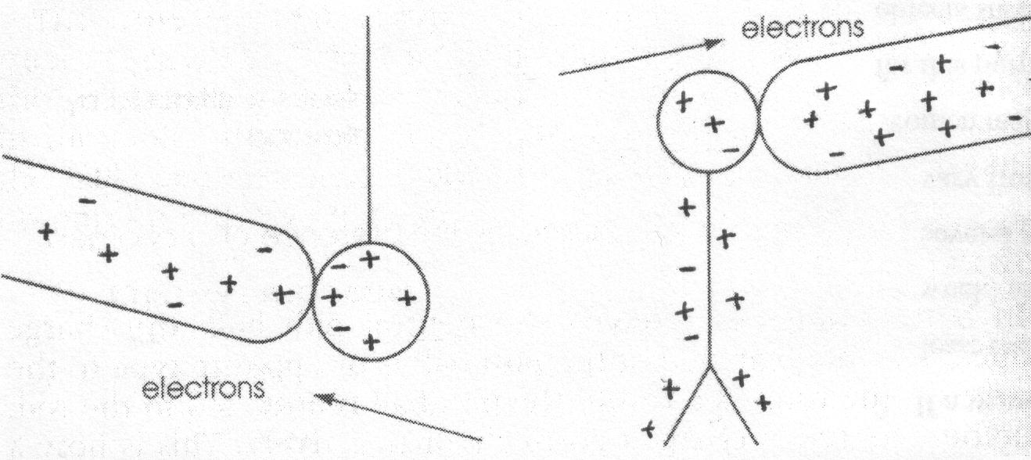
Note:
- Charging by conduction results in the electroscope receiving the same charge as the charging device and the charging device loses some, not all, of its charge in the process.
+
+
+
+
+
+
+
+
+
+
+
+
+
+
+
+
+
+
+
+
+
+
+
+
+
+
+
+
+
+
+
+
+
+
+
+
+
+
+
+
+
+
+
+
+
+
+
+
+
+
+
+
–
–
–
–
–
–
–
–
–
–
–
–
–
–
–
–
–
–
–
–
–
–
+22
+8
If a conducting object with an existing charge is brought into contact with another conducting object, the charges on both objects redistribute themselves. In the example to the right, we start with two positively charged spheres. Both spheres have the same surface area but they have different charges (+22 and +8).
+
+
+
+
+
+
+
+
+
+
+
+
+
+
+
+
+
+
+
+
+
+
+
+
+
+
–
–
–
–
–
–
–
–
–
–
–
+
+
+
+
+
+
+
+
+
+
+
+
+
+
+
+
+
+
+
+
+
+
+
+
+
+
–
–
–
–
–
–
–
–
–
–
–
+30
The spheres are then brought into contact. The charges redistribute themselves evenly between both spheres. Remember, the positive charges are found inside the nuclei of atoms that are fixed in position by the crystal structure of the metals. Only the negative electrons are free to flow. (Electrons have 1/1800th the mass of a proton and are therefore relatively easy to move.)
+
+
+
+
+
+
+
+
+
+
+
+
+
+
+
+
+
+
+
+
+
+
+
+
+
+
+
+
+
+
+
+
+
+
+
+
+
+
+
+
+
+
+
+
+
+
+
+
+
+
+
+
–
–
–
–
–
–
–
–
–
–
–
–
–
–
–
–
–
–
–
–
–
–
+15
+15

When the spheres are separated, the evenly distributed charges result in a +15 charge on each sphere.

If the surface areas of the spherical conductors are different, the sphere with the larger surface area will have proportionately more of the charges (i.e. if one sphere has twice the surface area of the other, it will have twice the charge.)
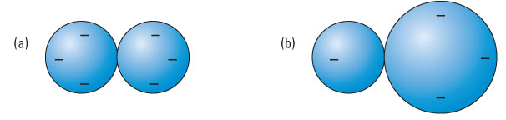

Charging By Induction (influence or induce)
We learned that a charged rod can induce a charge separation on a neutral conductor. When a negatively charged rod is brought near the knob of a neutral metal-leaf electroscope, free electrons on the electroscope move as far away as possible from the negative rod. When the charged object is removed from the area, the charges on the electroscope redistribute themselves and a neutral electroscope remains.
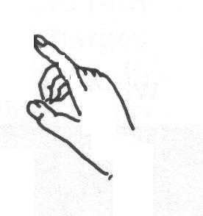
– – – – – – –
e⁻ flow out of electroscope
−
−
−
−
−
−
−
−
−
−
−
−
−
+
+
+
+
+
+
+
+
+
+
+
+
+
In order to give the electroscope or any conductor a permanent charge through induction another step is required. If, for example, a negatively charged rod is brought near the electroscope and you touch the electroscope with your finger, keeping the negative rod in place, electrons are induced to vacate the electroscope and flow through your finger. When your finger is removed, the electroscope is left with a deficit of electrons and, therefore, a positive charge. The leaves will remain apart even when the negative rod is removed.

The use of your finger acts as a ground through which electrons can either escape from the conductor or be pulled into the conductor.

A positively charged rod held near the knob of an electroscope induces electrons to move through your finger into the electroscope. Now, when your finger is removed, the electroscope is left with an excess of electrons – i.e. a negative charge.
+ + + + + + +
e⁻ flow into electroscope
−
−
−
−
−
−
−
−
−
−
−
−
−
+
+
+
+
+
+
+
+
+
+
+
+
+

Note:
- Charging by induction causes the object to become opposite in charge to the charging device and the charging device does not lose any charge in the process.

Pre-investigation hand-in assignment
Answer the following questions:

1. State the Law of Electric Charges.

2. What is the Law of Conservation of Charge?

3. If an object is electrically charged, what is this a result of? Which charges are relatively free to move and which are not free to move in a solid substance?

4. What is the difference between a conductor and an insulator?

5. One can transfer electrons from one object to another through friction by rubbing the two objects together. For each of the following pairs of materials that are rubbed together, state which material will become positively charged and which will become negatively charged:

brass ____ paraffin wax ____
wool ____ glass ____
wool ____ lead ____
paraffin wax ____ ebonite ____
ebonite ____ fur ____
glass ____ silk ____

6. If electrons are removed from an object it will have a net ___________ charge. If electrons are added to an object it will have a net ___________ charge.

7. What is the difference between an induced charge and an induced charge separation?

8. How does an electroscope appear when it is: (Draw a picture and give a short explanation for each one.)

A. neutral

B. positively charged

C. negatively charged

9. What is the procedure for giving an electroscope a positive charge by conduction.

10. What is the procedure for giving an electroscope a positive charge by induction.

11. If a negative rod is used to charge the object by conduction, the object will have a __________ charge.

12. If a negative rod is used to charge the object by induction, the object will have a __________ charge.

13. Two identical metal spheres have different charges. One has a charge of +10 C and the other has a charge of –20 C. If the spheres are allowed to touch each other for a time and then are moved away from each other, what is the final charge on each sphere? Explain.

14. Metal sphere A has a radius of 1.0 cm and a charge of –5.0 mC. Sphere A is brought into contact with metal sphere B which has a radius of 3.0 cm and was initially neutral. When they were separated what was the charge on each sphere? (The area of a sphere may be calculated using A = 4πr²). (–0.50 mC, –4.5 mC)

Electric Charge & The Transfer of Electric Charge Activity
Please read the following instructions carefully:
- In groups of two conduct the following investigations with the materials provided.
- Do the lab work together as a group and discuss the Questions together.
- Each member of the group should write the answers to the Questions for each of the investigations.
- Draw good diagrams, explaining what they mean.
- Remember, every member of the group is responsible for the knowledge gained in these activities.
- Enjoy yourselves and do not hesitate to ask for assistance and for explanations!!

Investigation 1 Induced Charge Separation

Problem:
How can a charged object cause charges on a nearby neutral object to move?

Materials:
pith-ball ebonite rod & fur (negative charge)
metal-leaf electroscope acetate & paper towel (positive charge)

Note: Experiments with charged objects work best on cool, dry days. Warm humid air, contains many positive and negative ions. If such air comes into contact with a charged object, the ions in the air will neutralize the charged object by contact. Also, moisture gets on charged surfaces and creates discharge paths. If your electroscope seems to be "leaking" its charge, this may be due to the humidity of the surrounding air.

Procedure:
1. Touch the pith ball with your finger to neutralize it. Rub the ebonite rod with the fur and bring it close to, but not touching, the pith ball. Carefully observe the motion of the pith ball.
2. Repeat the procedure using the acetate strip rubbed with a paper towel.
3. Touch the knob of the metal-leaf electroscope with your finger to neutralize it. Charge an ebonite rod, and bring it close to, but not touching, the knob of the electroscope. Observe the motion of the metal leaves as the rod is brought near, and when as it is removed.
4. Repeat, using the acetate strip rubbed with a paper towel.

Questions:
1. As the charged ebonite rod was brought near the pith-ball electroscope, which way did the pith ball begin to move? Why? Draw a sketch to show the pith ball, with the charged rod near it, and the effect of the rod on the positive and negative charges on the neutral pith ball.
2. Which way does the pith ball move when the charged acetate strip is brought close to it? Why? Draw another sketch showing the new distribution of charge on the neutral pith ball.
3. As each rod is brought near to the knob of the metal-leaf electroscope, what happens to the leaves? Why? Draw sketches to show the distribution of charge on the knob and leaves of the electroscope, in each case.
4. What happens to the leaves when the charged rods are removed? Why? What is the net charge on the electroscope?
5. Why does touching an object with your hand ensure that it is neutral? Be sure your explanation covers both cases: when the object has an excess of electrons, as well as when it has a deficit.
6. When a nearby charged object causes a change in the distribution of charge on a neutral object, this is called an induced charge separation. Is it possible to create an induced charge separation on an insulator? On a conductor? Explain your answers.

Investigation 2 Charging by Conduction/Contact

Problem:
How can you charge an object by contact?

Note: Just before contact is made between the charged ebonite rod and the neutral electroscope, a small spark composed of "over-anxious" electrons may be observed jumping from the rod to the electroscope.

Procedure:
1. Neutralize the pith-ball by touching it with your finger. Charge an ebonite rod and touch it to the pith ball. Then bring the rod close to the pith ball again and observe the pith ball's motion.
2. Repeat the procedure using the acetate strip rubbed with paper towel.
3. Neutralize the metal-leaf electroscope with your finger. Now touch the knob with the (charged) ebonite rod, and observe the motion of the leaves after the rod has been removed.
4. Repeat, using the acetate strip rubbed with paper towel.
5. Charge the metal-leaf electroscope by touching the knob with the (charged) ebonite rod. Recharge the ebonite rod and bring it close to, but not touching, the knob. Notice the effect on the leaves. Now bring the (charged) acetate strip close, and notice its effect on the leaves.
6. Repeat the same steps, but this time use the metal-leaf electroscope, charged by contact with the (charged) acetate strip.

Questions:
1. When the charged ebonite rod touched the pith ball, what charge did the pith ball acquire? How do you know? Which way did the electrons move? Illustrate your answers with sketches labelled "before contact", "during contact", and "after contact".
2. When the charged acetate strip touched the pith ball, what charge did the pith ball acquire? Once again, draw sketches to illustrate your answers.
3. What charge did the metal-leaf electroscope acquire when it was touched with the charged ebonite rod? Draw a sketch representing the electroscope after the rod was removed.
4. What charge did the metal-leaf electroscope acquire when it was touched with the charged acetate strip? Once again, draw a sketch representing the electroscope after the rod was removed.
5. When an object is charged by contact, what charge does it acquire, as compared with the charge on the rod?
6. When a rod of the same charge is brought close to the knob of a charged metal-leaf electroscope, what is the effect on the metal leaves? Draw a sketch that explains that effect.
7. When a rod of the opposite charge is brought close to the knob of a charged metal-leaf electroscope, what effect does this have on the metal leaves? Again, draw an explanatory sketch.

Investigation 3 Charging by Induction
Problem:
How can you charge an object by induction?

Materials:
pith-ball ebonite rod and fur
metal-leaf electroscope acetate strip and paper towel
2 short metal rods 2 glass beakers (250 mL)

Procedure:
1. Place two short metal rods across the top of each of two beakers and arrange the beakers so that the ends of the rods touch. Now bring the (charged) ebonite rod near the end of one of the rods, but not touching it. (If a spark jumps start over again. This time, do not bring the ebonite rod quite so close to the metal rod.) While the ebonite rod is influencing the rods, separate the two rods by moving only the far beaker, taking care not to touch the metal rod. Finally remove the ebonite rod from the vicinity. Test the metal rods, in turn, for a charge by bringing a pith-ball with a known charge near them. Note how the pith ball responds to each rod – the effect is usually very subtle, so observe carefully. Bring the metal rods into contact again and test them for a charge while they are touching. (If the rod does accidentally touch the pith ball, ground the pith ball with your finger and start over again.)
metal rod #1
metal rod #2
beakers
2. Move the metal-leaf electroscope so that it slightly hangs over the edge of the table. Neutralize the metal-leaf electroscope. Bring the (charged) ebonite rod near to, but not touching, the bottom of the electroscope. Touch the knob with your finger, and observe the leaves. Remove your finger, and then remove the rod. Observe the motion of the leaves. Bring the rod near the knob, and observe its effect on the leaves.
3. Repeat the entire procedure, using the (charged) acetate strip.

Questions:
1. Why were the metal rods placed on glass beakers? What effect did the ebonite rod have on some electrons in the touching metal rods? Draw sketches to show the ebonite rod, the two metal rods touching, and the distribution of charge on the rods. When the rods were separated, what was the charge on each of them? What charge was on each rod after they were made to touch again? Explain your answers.
2. What would have been different about the resultant charge on each rod if a charged acetate strip had been used instead of a charged ebonite rod? Illustrate your answer with a sketch.
3. Why did the leaves of the metal-leaf electroscope move apart when the charged ebonite rod was brought near? When you touched the knob with your finger, what was happening in your finger? Why were you told to remove your finger before removing the rod? Draw sketches to show what was happening before, during, and after contact with the knob by your finger.
4. Why did the leaves move apart when the charged acetate strip was brought near? What was happening in your finger, this time, when it touched the knob? Again, illustrate your answers.
5. When an object is charged by induction, what charge does it acquire compared with the charge on the rod?

Investigation 4 Dancing paper

Problem:
Why are small pieces of paper attracted to a charged rod?

Materials:
3 or 4 small slips of paper (0.5 cm x 1.0 cm) ebonite rod and fur

Procedure:
1. Place the slips of paper on a table. Charge the rod and then place it over the bits of paper. Note what happens.

Questions:
1. Using diagrams, explain why the slips of paper were attracted to the charged rod.

2. In Investigation 2 you observed that when a pith ball contacted the ebonite rod it immediately became repulsed by the ebonite rod after contact. Why do the slips of paper stick to the ebonite rod rather than being repulsed by the ebonite rod after contact?
(For this question, it is wise to check your answer with your teacher.)

