Physics 30 Lesson 19 Magnetic fields
Prior to 1820, scientists believed that there was no relationship between electricity and magnetism. Repeated tests had shown that permanent magnets do not effect static charges. The text books of the day had two separate sections, one on electricity and another on magnetism. No one suspected that, in reality, electricity and magnetism were intimately related.

Permanent magnets
There are only certain materials which can either be made into a permanent magnet or be attracted by a magnetic field. These kinds of materials are called ferromagnetic substances. A ferromagnetic substance is one that can be attracted by a magnet or be turned into a permanent magnet. Ferromagnetic materials include iron, nickel, cobalt and alloys of iron such as alnico. One theory that attempts to explain the behavior of ferromagnetic materials is the domain theory of magnetism.

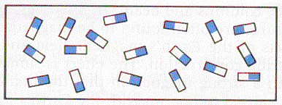
According to the domain theory, all ferromagnetic substances are composed of a large number of regions (less than 1 μm long) called magnetic domains. Each domain behaves like a tiny bar magnet. When a ferromagnetic object is in an unmagnetized state, the millions of domains are oriented at random so that their combined magnetic effects cancel each other out as the diagram to the right illustrates.

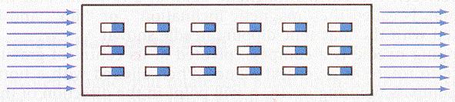
However if a ferromagnetic object is placed in a magnetic field, some of the domains rotate to align themselves with the external magnetic field. The stronger the external magnetic field, the greater the number of domains that will align themselves. The net result is that a preferred orientation of the domains (in the same direction as the external field) causes the material to behave like a magnet. When the external magnetic field is removed, this orientation may remain for a long time or may disappear immediately depending on the type of material.

The domain theory provides a simple explanation for many properties of induced magnets:
- A needle can be magnetized by stroking it in one direction with a permanent magnet, thereby aligning its domains.
- When a bar magnet is broken in two, rather than producing separate north and south poles, two smaller magnets are produced, each with its own north and south poles.
- Some induced magnets made of soft iron demagnetize instantaneously while others made of hard steel or alloys remain magnetized indefinitely. Impurities in alloys seem to lock the aligned domains in place.
- Heating, hammering or dropping a magnet can cause a magnet to lose its magnetization. The domains are jostled from an aligned pattern into a random pattern.
- A strong magnet can reverse the magnetism in a bar magnet. This occurs when the domains reverse their direction in the presence of a strong external magnetic field.
- Ship’s hulls, steel columns and beams in buildings, and many other ferromagnetic structures are often found to be magnetized by the combined effects of the Earth’s magnetic field and the vibrations created during construction.
- Some ferromagnetic minerals will have a magnetic field aligned with that of the Earth’s magnetic field. The domains in the minerals align themselves with the external field of the Earth.
Refer to Pearson pages 589 to 591 for a discussion about the domain theory of magnetism.

Magnetic fields
Like the Rules of Charge that describe electrical interactions, the Rules for Magnetism are:
- There are two kinds of magnetic poles (North and South).
- Like poles repel.
- Unlike poles attract.

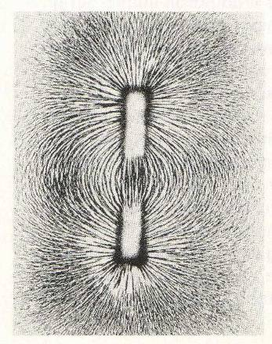
A magnetic pole is a region of the magnet where its strength is greatest. Every magnet has two poles. In fact, magnets are always bipolar – i.e. there are no isolated magnetic poles. This is, of course, different from electric charges that can and do occur in isolation. Do not confuse North and South magnetic poles with + and − charges. Magnetic poles do not attract or repel electric charges.

The magnetic field around a magnet can be easily observed by sprinkling iron filings on a horizontal surface in the field. The domains in the little iron filings are aligned by the field and then behave like magnetic compass needles which align themselves in the direction of the field.

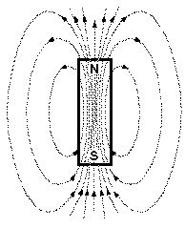
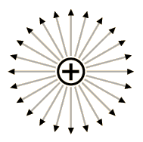
In a diagram of a magnetic field, the magnetic field is represented by magnetic lines of force, which are also called magnetic flux lines. These lines are imaginary. The stronger a magnet, the greater the number of flux lines. It must be noted that, as the diagram to the right illustrates, the magnetic field lines continue through the magnetic domains within the magnet and are therefore continuous. Whereas gravitational field lines originate from a mass and electric field lines originate from positive charges, magnetic field lines have no beginning and no end.
However, the majority of the time we only draw the field lines of interest. For a bar magnet we often draw the external field lines to represent the magnetic field. Outside of the magnet, their direction is from the N-pole to the S-pole.
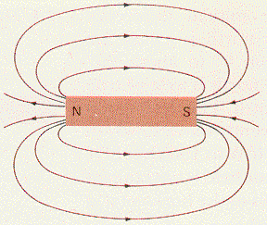

The Earth has a magnetic field that acts as if it had a giant magnet inside it. Note that the north end of a compass points toward the geographic north pole. However, as we learned earlier, the north pole of a compass is attracted to the south pole of a magnet. This leads us to conclude that there is a south magnetic pole at the north geographic pole of the Earth. Likewise, there is a north magnetic pole at the south geographic pole of the Earth.
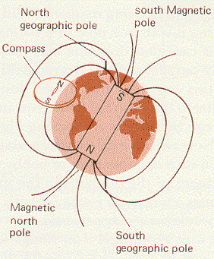

Refer to Pearson pages 585 and 586 for a discussion about magnetic fields.

Oersted’s demonstration
As stated earlier, in the early 19th century people did not know of the relationship between electricity and magnetism. In 1820, Hans Oersted (1777 – 1851) accidentally made a discovery that was to have major effects on the use of electricity. His discovery would lead to the development of the electric motor and the generator within eleven years.

Oersted was a professor and one day he was using one of Volta’s electrochemical cells to demonstrate that an electric current in a wire produces heat. While doing the demonstration he noticed that a nearby magnet would always turn when the current in the wire was turned on. To investigate, he placed a small compass under the wire so that the copper wire conductor and the compass needle were parallel. When he turned the current on the compass needle moved so that it became perpendicular to the current carrying wire. In fact, when he placed the compass above the current carrying wire it pointed in one direction and when placed below the wire it pointed in the opposite direction. With his discovery, Oersted became famous over night.
no current
N

S
compass below wire
current
flow
N S
compass above wire
current
flow
S N

The key idea is:
Current through a conducting wire induces a magnetic field around the wire in a plane that is perpendicular to the wire. In addition, the relative motion of a charged particle induces a magnetic field around the particle.

Warning: Many students get caught up in the hand rules that are presented in the next section, and they forget the main idea that current-carrying wires and moving charges have induced magnetic fields around them. Refer to Pearson pages 587 and 588 for a discussion about induced magnetic fields.

First hand rule – current carrying wires
Before proceeding, recall from Lesson 18:
- The terms current and conventional current refer to the movement of positive charges.
- Electron current or electron flow refers to the movement of negative charges.

In order to predict the direction of the magnetic field around a current carrying wire, we use hand rules. There are three hand rules we will be using:
- The first hand rule indicates the direction of the magnetic field around a current carrying wire.
- The second hand rule indicates the magnetic field direction for a coil of wire (i.e. a solenoid).
- The third hand rule (which we will deal with in Lessons 20 and 21) indicates the direction of the force when a charged particle enters a magnetic field.

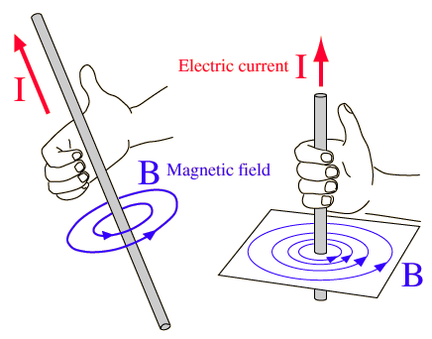
One thing that is common to all of the hand rules is that the left hand is used for electron current (negative charges) and the right hand is used when referring to conventional current (positive charges).

The first hand rule indicates the direction of the magnetic field around a current-carrying wire. For a current carrying wire the thumb points in the direction of the current and the fingers curl around the wire indicating the direction of the magnetic field. Note that the direction of the magnetic field is around the wire.

Note that the magnetic field around a current carrying wire is in three-dimensional space. In the diagrams above, for example, the current carrying wires are surrounded by magnetic fields that are not in the plane of the paper. We could also represent the same situation as a vertical wire with the current coming out of the page as shown in the diagram to the right.
•
B (magnetic field lines)
cross-section of conductor
A • represents a direction out of the page and a represents a direction into the page. (Imagine the point of an arrow • coming toward you and the feathers of the arrow as it moves away from you.)

A wire is placed under a compass needle and electrons are allowed to flow from A to B as shown in the diagram. What direction will the compass needle point?
B
A
electrons
Using the left hand (i.e. electron flow), we find that on top of the wire your fingers point to the right. This tells us that the north end of the compass will point to the right.

A wire is placed over a compass needle and current flows from A to B as shown in the diagram. What direction will the compass needle point?
B
A
current
Using the right hand (i.e. current), we find that below the wire your fingers point to the right. This tells us that the north end of the compass will point to the right.

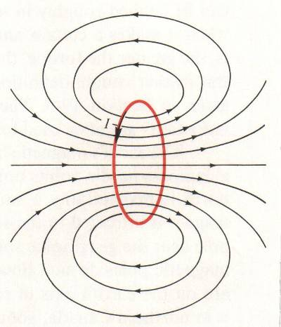
Second hand rule – solenoids (loops or coils of wire)
When a long conducting wire is bent into a loop, the magnetic field from each point in the loop points in the same direction. The result is a strong magnetic field inside the loop of wire.

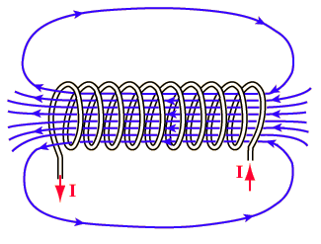
If more turns of wire are wrapped repeatedly we have a coil of wire, a solenoid, and our generated field will become stronger while its direction remains constant. This is called an electromagnet since the electric current through the loops of wire results in a strong, uniform magnetic field. The strength of the electromagnet will depend on the number of loops in the solenoid and the amount of current flowing through the loops.

To determine the direction of the magnetic field in the core of the solenoid, we use the second hand rule. The fingers curl in the direction of the current (right hand) or the electron flow (left hand). The thumb will point in the direction of the magnetic field lines in the core of the solenoid and, hence, towards the north pole of the electromagnet. Note that the magnetic field of an electromagnet is similar to the field of a bar magnet.
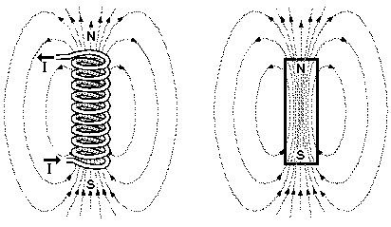

In the diagram below if current flows from A to B, which end of the coil is north?
B
A
N
B
A
S

solution – Draw in arrows on the solenoid to indicate the direction of current flow. Since we are dealing with current we use the right hand. The fingers of the right hand point in the direction of the current and the thumb points in the North direction for the induced magnetic field. In this case the north pole is to the right and the south pole to the left.

In the diagram below if current flows from A to B, which end of the coil is north?

B
A
S
N
B
A

solution – Draw in arrows on the solenoid to indicate the direction of current flow. In this case the north pole is to the left and the south pole to the right. Note the difference between this example and example 3 is that the winding of the solenoids are opposite.

Magnetic, gravitational and electric fields
The idea of a field of influence resulted from a need to explain how one object (for example a magnet) can have an effect on another object (an iron nail) over a distance. How does an iron nail "know" about the presence of the magnet? Conversely, how does the magnet “know” about the nail? After all, the magnet and the nail are not in direct contact. Similarly, how does the Earth “know” about the presence of the Sun? Or how does a proton become attracted to an electron? It is this action at a distance for which the concept of a field was developed. This type of influence at a distance is referred to as a field.

Gravitational Fields
We studied gravity in Physics 20 where it was described as the attraction between two masses. In terms of fields, one object responded to the gravitational field of another object. For example, near the surface of the Earth all objects, regardless of size or shape, are subject to an average acceleration due to gravity of 9.81 m/s² acting toward the center of the Earth. Another name for this acceleration is gravitational field strength. Near the surface of the Earth, the gravitational field strength is 9.81 m/s² downward. As you move away from the center of the Earth, the gravitational field strength decreases in magnitude, but its direction remains unchanged. The gravitational field strength is different for different planets and moons. The gravitational field strength for a planet or moon is calculated using the following formula:
${\vec{a}}_{g}=−G\frac{M}{r^{2}}\text{units}:(N/{\text{kg}})\text{or}(m/{s^{2}})$
Some confusion may exist between the concepts of gravitational field strength and gravitational force. Consider three objects like those depicted below.

F_{g}
F_{g}
F_{g}
10 kg
100 kg
1000 kg
Each object experiences the same gravitational field strength of -9.81 m/s².
Each object experiences a different force since each object has a different mass.

${\vec{F}}_{g}=m{\vec{a}}_{g}$
Unlike magnets which may attract or repel depending on which poles are interacting, gravitational fields are always attractive. Gravitational fields have the following characteristics:
- Gravitational fields exist between any objects which have mass.
- Massive objects always attract, they never repel.
- Gravitational fields decrease in strength with increased distance.
- Gravitational fields have a vector nature.

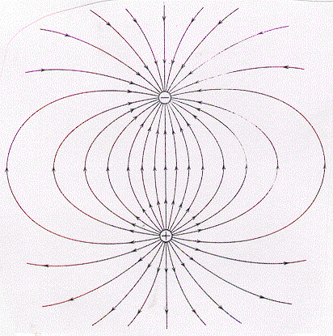
Electric Fields
As we saw in Lesson 15, an electric field is generated by any object which has an electric charge. Electric fields have the following characteristics:
- Electric fields can be produced by either positive or negative charged objects.
- Like charges repel, unlike charges attract.
- Electric fields decrease in strength with increased distance.
- Electric fields have a vector nature.

Magnetic Fields
As we saw in this lesson, magnetic fields can be produced by aligned magnetic domains or they can be induced by current-carrying wires.
Magnetic fields have the following characteristics:
- Magnets are always bipolar, possessing a north and a south pole. (No magnetic monopoles have ever been detected.)
- Similar poles repel, opposite poles attract.
- Magnetic fields decrease in strength with increased distance from the magnet.
- Magnetic fields have a vector nature. Objects move in a particular direction when they are brought into the proximity of a magnet.
- Unlike gravitational fields which point toward a mass or electric fields which originate from charges, magnetic field lines are always circular without a beginning and without an end.

Practice problems
For the following diagrams, draw in the appropriate magnetic field lines including direction. In the small circles, draw an arrow to indicate the direction that a small compass needle would point if it were placed in that location. Where applicable indicate whether the force between objects will be attractive or repulsive.
N
S
compass

1.

2.
S
N

The force between the magnets is __________

3.
N
N

The force between the magnets is __________

4. Cross-sections of wire.

•
×
e⁻
e⁻

The force between the wires is __________

5.

•
•
e⁻
e⁻

The force between the wires is __________

6.
I

7.
I

Hand-in assignment
Part A
1. In the diagram below, a compass is placed under the conductor and the conductor is carrying conventional current from A to B. In which direction will the compass needle point?
A
B
answer here

2. In the diagram below, a compass is placed over a conductor and the conductor is carrying electrons from B to A. In which direction will the compass needle point?
A
B

3. In the diagram below, the compass is pointing toward the right side of the page. In which direction is current flowing in the conductor, A to B or B to A?
A
B
_____ to _____

4. In the diagram below, the circle represents the cross-section of a conductor coming out of the page. The direction of the current is represented by the dot in the centre of the conductor. In what direction will a compass needle point if it is placed at point P?

•
P •

5. In the diagram, electrons are flowing from A to B. Which end of the solenoid becomes the north pole?
B
A

6. In the diagram, current is flowing from A to B. Which end of the solenoid becomes the south pole?
B
A

B
A

7. In the diagram, the top of the solenoid is the induced north pole. Which way is the current flowing, A to B or B to A?

Part B
1. Draw the magnetic field lines for the following configurations. Indicate whether the objects experience an attractive or repulsive magnetic force. Do the drawings on a separate piece of paper. (Do not cram them onto this page.)

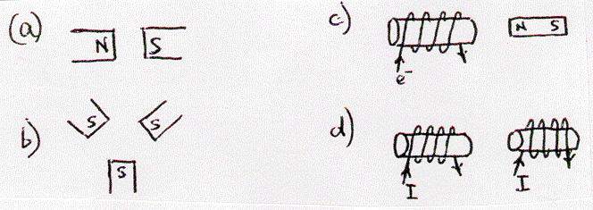

2. A magnetic compass is allowed to come to rest in a north-south orientation. A wire is placed over it, and connected so that the electron flow is from north to south. Will the compass needle deflect clockwise or counterclockwise as seen from above?

3. A wire is connected in a North-South direction and a compass is placed over top of the wire and allowed to come to rest in the North-South direction. Electrons are allowed to flow through the wire from North to South. Will the compass needle deflect clockwise or counterclockwise as seen from above?

4. A magnetic compass is allowed to come to rest in a North-South direction. A wire is placed over it and connected so that the electrons flow from South to North. Will the compass needle deflect clockwise or counterclockwise as seen from above?

5. A wire is connected in a North-South direction and a compass is placed over top of the wire and allowed to come to rest in the North-South direction. Electrons are allowed to flow through the wire from South to North. Will the compass needle deflect clockwise or counterclockwise as seen from above?

6. If you fire a negatively charged bullet horizontally and watch it recede away from you, what is the direction of the magnetic field that surrounds it? (clockwise or counterclockwise)

7. If you fire a positively charged bullet horizontally and watch it recede, what is the direction of the magnetic field that surrounds it?

8. A coil of wire is placed on a table with its axis in the vertical direction. A flow of electrons is sent through the wire in the counterclockwise direction as seen from above. In which direction (up or down) is the North end of the magnetic field inside the coil generated?

9. (a) A large flat plastic disk is negatively charged. if the disk is spinning clockwise as seen from above, in what direction (up or down) will the North end of the generated magnetic field point?
(b) Answer the same question for a positively charged disk.

10. Is the North Magnetic Pole area on Earth a North Pole or a South Pole? Explain using a diagram of the Earth’s magnetic field.

11. A compass responds to the horizontal component of the Earth’s magnetic field. Describe the action of a magnetic compass:
a. the north pole
b. the south pole
c. the equator

12. Iron pipes, steel beams, and other steel structures that remain stationary are often found to be magnetized with a distinct polarity. Explain.

13. The following diagram shows a compass placed near the end of a bar magnet. Use arrows to sketch the alignment of the domains within the bar magnet.

N

14. Identify the sources of electric fields, magnetic fields, and gravitational fields.

15. Briefly describe the domain theory of magnetism.

16. Compare and contrast gravitational, electric, and magnetic fields. Show how they are similar and how they differ from one another.

17. What is the difference between a scalar and a vector field?

Electromagnetism Activity

For this activity there are two stations, Oersted’s demonstration and a solenoid. The purpose of the activity is for you to investigate how current-carrying wires and solenoids generate a magnetic field. Further, you will be able to see how the hand rules work for each situation. If you run into difficulties explaining what you are seeing, ask your teacher for help.

Note:
- For each station there is a current-limiting-resistor in the circuit which is there to limit the current and thereby save the power supplies from burning out. Leave them in the circuit at all times.

- Many of the items you will be using are easily damaged and/or destroyed through improper use. The instructions given are designed for the safe and proper use of the materials. If you have any questions about how something should be hooked up, ask before you turn on the power.

Station 1 Oersted’s demonstration

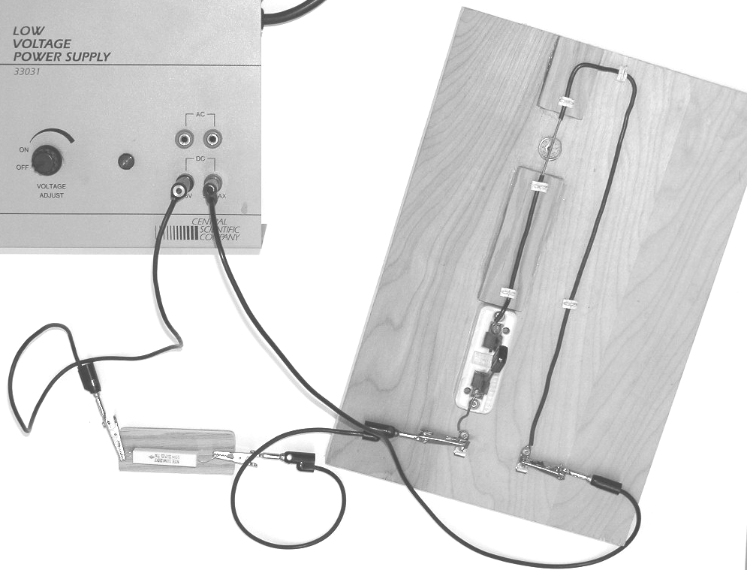
In this apparatus, a wire has been horizontally suspended so that a compass can be placed below or above the wire. As the picture shows, the apparatus has been turned so that the compass needle and wire are parallel when the current is turned off. The wire is hooked up to a power supply through a current-limiting-resistor. Due to the large current involved, switch the power on for a few seconds at a time only.
current-limiting resistor
compass
under wire
switch

Procedure:
- Before turning on the power, place a compass below the wire and note the direction that the needle points. (The needle should be parallel to the wire.) You should also determine which end of the compass needle is the north magnetic pole.
- Turn on the power. Place a compass first below and then above the wire and note the direction that the needle points.
- Check to see if the behaviour of the compass above and below the wire matches the directions predicted by the appropriate hand rule. (Electrons flow from the black terminal to the red terminal of the power supply.)
- Turn off the power. Reverse the polarity of the wires at the power source. Repeat #2 and #3.
Questions:
- Does the direction of the magnetic field predicted by the hand rule agree with your observations? Draw a diagram of the magnetic field around a current-carrying wire.

- What is the purpose and function of using a compass in this activity?

Station 2 Solenoid – electromagnet

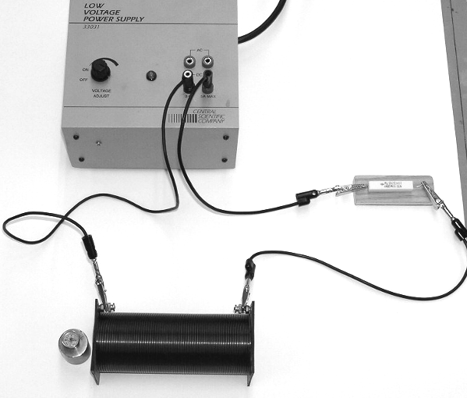
In this apparatus, a plastic-coated wire has been wrapped many times around a plastic tube to form a solenoid. The solenoid is hooked up to a power supply through a current-limiting-resistor. Switch the power on for a few minutes at a time only.
solenoid

Procedure:
- Before turning the power supply on, use a compass to test around and within the solenoid for a magnetic field.
- Turn on the power. Test the direction of the magnetic field through the centre axis or core of the solenoid.
- Test the direction of the magnetic field on the outside of the solenoid.
- Turn the power off, reverse the output jacks at the power supply. Repeat #2 and #3.
Questions:
- Using the appropriate hand rule, does the direction of the magnetic field predicted by the hand rule agree with your observations? Draw a diagram of the magnetic field generated in a solenoid.

- Compare and contrast an electromagnet and a bar magnet.

